Black People Matter Curriculum
Unitarian Universalist Church of Amherst
Parents Newsletter for Week #1 – January 8, 2017
WHAT is this thing called color?

Asking questions such as: Are we really Black or White? If not, then how could I describe my skin tone? What is beauty?
Today’s participants had a choice of hands-on activities that helped form questions for them to think about. Using a variety of materials students explored what color really is and how many skin tones there really are.
Using magazines, collages were created to depict the variations of beauty.

Here are some book suggestions that relate to today’s activities:
Black is Brown is Tan by Arnold Adoff ages K and up
Looking Like Me by Walter Myers and Christopher Myers K-4th
Shades of People by Shelly Rotner and Sheila Kelly K-1st
I Love My Hair by Natasha Anastasia Tarpley K
Let’s Talk About Race by Julius Lester K-3rd
These and many more books were available for children and youth to browse today. Many are appropriate for ages younger and older than those listed. You are invited to borrow books FOR A MAXIMUM OF 1 WEEK – sign out on the hall bulletin board, and pick up a free annotated bibliography of the books we will be using or having available. Additional resources will also be posted on uuamherst.org. Do you have anything helpful to share?
Please talk to your child about what happened today, and keep the conversation going!
Next Sunday our topic is SO WHAT? What does it take to be a hero?
As always, our Interim Director of Faith Development Karen LoBracco is interested in partnering with you in supporting your child’s spiritual development. Let’s talk – (585)730-0686 or dfd@uuamherst.org!
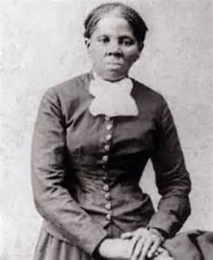 Black People Matter Curriculum 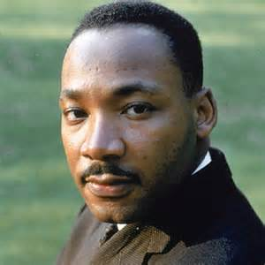
Parents Newsletter for Week #3 – January 22, 2017
NOW WHAT?
Our Gathering experience challenged us: should our goal be Equality, Fairness or Justice? We SAW the difference-so Now What?
Activity #1 Friendship, especially in times of challenge.
In times of conflict it is sometimes hard to reach out to make new friends, as well as continue to be in relationship with old friends. What can we do to include rather than exclude? We practiced those hard conversations using lollypop puppets.
Activity #2 Anti-Racist White Heroes
Yes, white people can be anti-racist heroes, and we met several from history and from our congregation. The challenge for white people is to learn how to be an ally – someone who supports and follows the lead of others. Participants in this group completed a sheet I can help by….
Activity #3 Designing an Equal or Fair or Just School
If we were in charge of designing the ideal classroom or school, what would it look and feel like? More than discussion, this group focused on “building” and demonstrating a better way. Come check it out!

Here is a link you might find helpful as we journey through this curriculum and through the upcoming year:
http://www.uuamherst.org/january-intersession-black-people-matter-take-2/
As always, our Interim Director of Faith Development Karen LoBracco is interested in partnering with you in supporting your child’s spiritual development. Let’s talk – (585)730-0686 or dfd@uuamherst.org! “Regular” faith development programs resume next Sunday, January 29.

